**Assignment 113**

**Sand Setup**

Last modified 7 January

This assignment is due to be completed and submitted by noon Thursday, 13 January.

Everything in this assignment is CASE SENSITIVE! Spaces and punctuation matter!

1. Log into sand. The preferred way is to point a browser at <https://sand.truman.edu/vnc/> You should see this: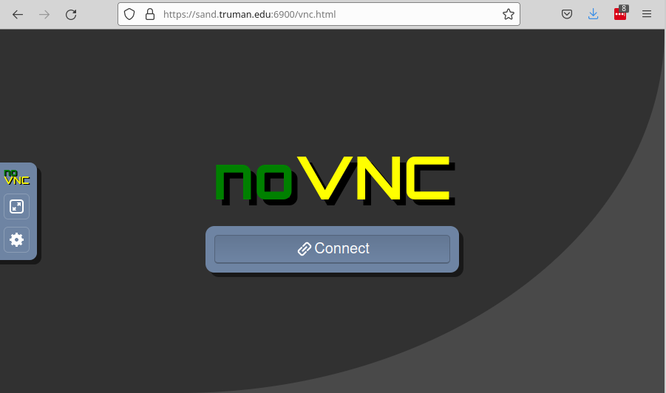  
   Click on Connect, then type your name into the “Login name:" box.  WAIT! Do not press Go yet.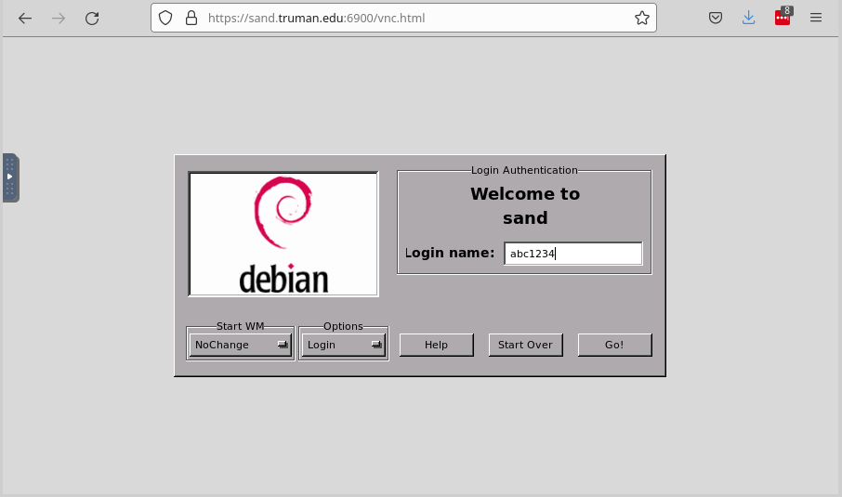  
   Press the TAB key to get the “Password:” box.  WAIT! Do not press Go yet.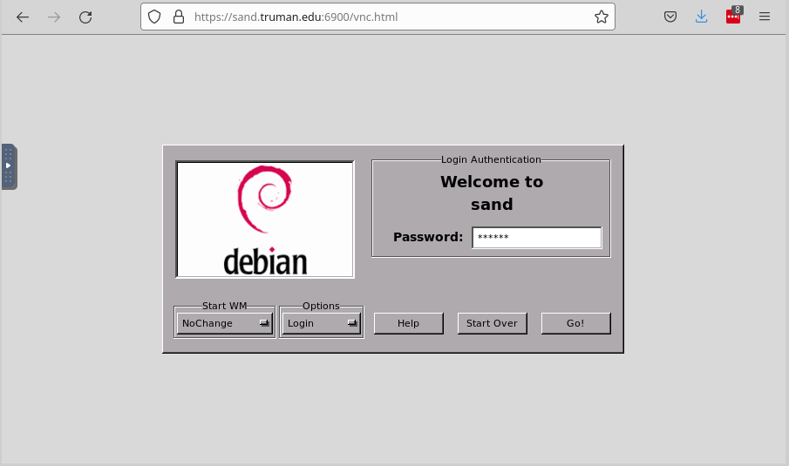  
   Click the Start WM dropdown list and select xfce4-session. Now you can click on Go!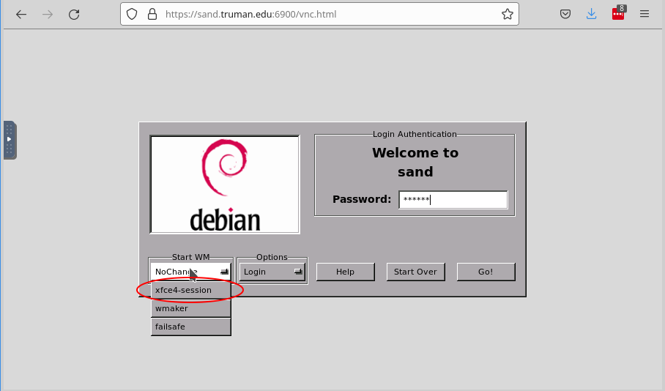
2. Customize the desktop. Pull out the Control Bar tab on the left-hand side and select the Gear settings menu. Check the Clip to Window checkbox, and choose the Remote Resizing setting. Also click on Fullscreen button to get maximum real estate in your window.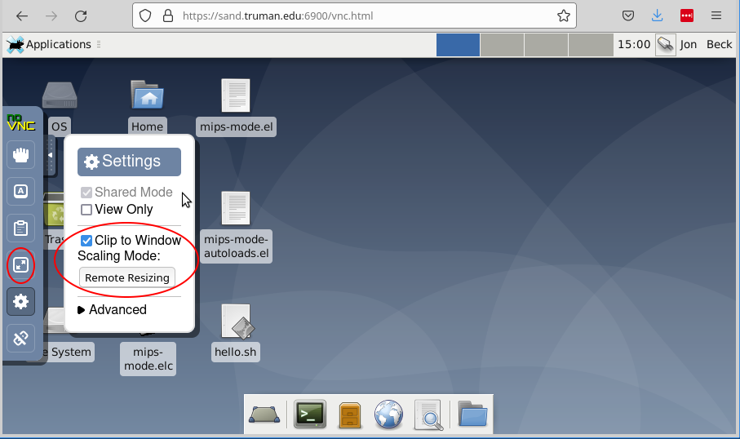
3. Open a terminal window by clicking on the Terminal icon in the bottom tray. Or click Applications → Terminal Emulator.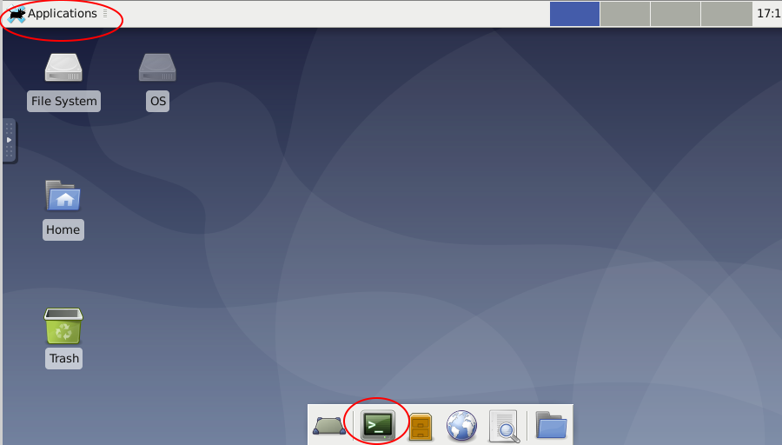  
   This will open a BASH shell window at which you can enter BASH commands.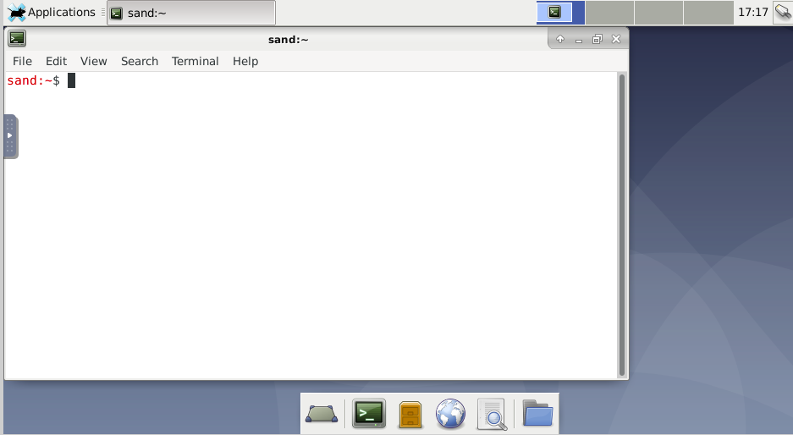
4. All subsequent commands will be at the $ prompt in the terminal window. Issue the command ls, and you will see the list of files and directories in your home directory:
5. $ ls
6. cs191 cs310 Documents Music Public Videos

cs250 Desktop Downloads Pictures Templates

Your list will probably be different. The key item is whether you have a directory named “public_html” in your list. In my list above, I do not. If you do, go on to the next step. If not, create this directory, and then confirm that it is now in your list:

$ mkdir public_html

$ ls

cs191 cs310 Documents Music Public Templates

cs250 Desktop Downloads Pictures public_html Videos

1. Change the security permissions of your home directory and your public_html directory:
2. $ chmod 701 $HOME

$ chmod 701 public_html

1. You now need to create a file named “.htaccess” in your public_html directory. This is a good time to decide upon a code editor to use. sand has a number of code editors:
   * Applications → Accessories → gVim
   * Applications → Development → Bluefish Editor
   * Applications → Development → Emacs (GUI)
   * Applications → Development → Geany
   * Applications → Development → Visual Studio Code
   * Applications → Development → SciTE

The classic editors are gVim and Emacs. Bluefish is optimized for web programming, Geany is easy to use, and SciTE is fast and simple.  
  
Regardless of the editor you choose, you must configure it for

* + 2-space indent levels
  + spaces, not tabs, for indenting

If you can't make your editor do that for you, choose a different editor.  
  
Using the editor of your choice, create a file named .htaccess in your public_html directory. The contents of the file must be exactly:

Order Allow,Deny

Allow from all

1. At the terminal prompt, set the correct security permissions on the .htaccess file:

$ chmod 644 public_html/.htaccess

1. Using the text editor, create a file named hello.html in your public_html directory. The contents of the file don't really matter, but I suggest:

Hello, world!

1. At the terminal prompt, set the correct security permissions on the hello.html file:

$ chmod 644 public_html/hello.html

1. Confirm that you can see the contents of the file on the web. In a browser, enter the address:

https://sand.truman.edu/~abc1234/hello.html

except replace “abc1234” with your Truman username. The contents of your hello.html file should appear in the browser like this:  
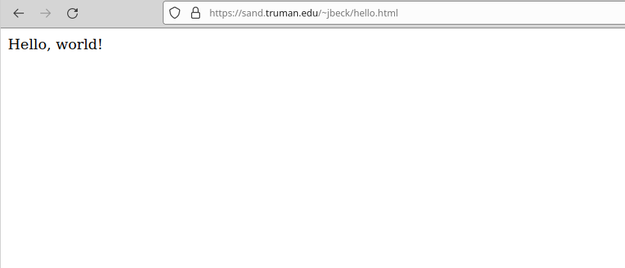  
If so, you have done the heavy lifting of the assignment and are ready to submit. If not, then carefully read the error message or condition, retrace the above steps, and see if you can fix the problem. If you still have trouble, contact me, letting me know exactly what you did, which step you had trouble on, and what the trouble was.

1. Submit your homework. Create one more text file that contains one single line:

https://sand.truman.edu/~abc1234/hello.html

except again replace abc1234 with your username. It doesn't matter what the name of this file is, except the extension must be .txt. You can create this file on your own computer or on sand. On the same system where the file is, navigate a browser to <https://borax.truman.edu/315/submit.php> and upload the .txt file to the course submission page, and submit. You should get a success message.

1. Log out of sand cleanly by doing Applications → Log Out. Don't just close the vnc window; if you do, it's easy to get locked out of sand. If you do get locked out, and for lots of other useful information, please see the [FAQ](https://sand.truman.edu/faq) that Dr. Bindner maintains.